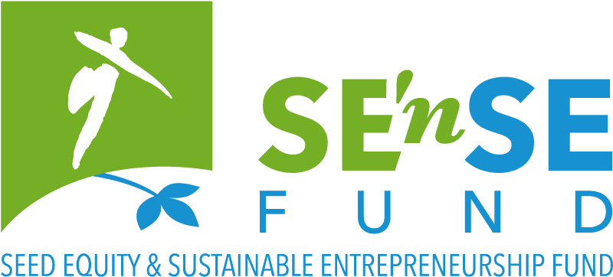


SE’nSE call for projects for
sustainable start-ups
Seed financing for early stage, sustainable
start-ups with positive environmental impact

APPLICATION FORM
Call for projects 2026

This application form and the requested annexes must be completed in English and uploaded before midnight on the 16th of August, on the Foundation for Future Generations’ website.

Based on the investor pitch deck the jury will pre-select 4 to 8 projects. They will be invited to pitch their project in front of the jury on the 8th of October in Louvain-la-Neuve. (! Please already block this date)
Please be as clear and concise as possible.
The character limits for answers include spaces.

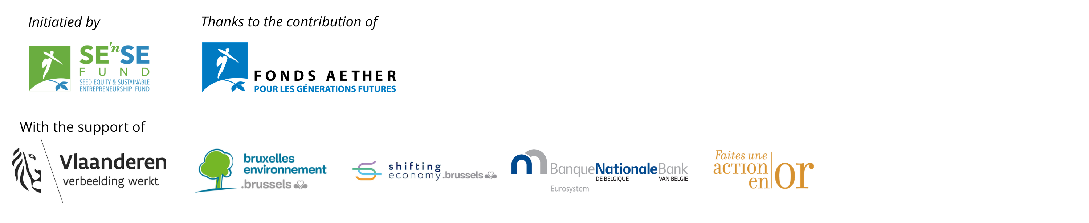

The project
Name of the company | Click or tap here to enter text.

Briefly describe your product/service, the environmental/societal needs/problems it seeks to address and the key impacts expected.
This short pitch might be used in future public communication (newsletter, website, annual report), with your consent, so please be as clear and as concrete as possible (max.1200 characters incl. spaces).
Click or tap here to enter text.

Field(s) of activity
Select max. 5 primary fields in which your project is/will be active:
☐ Architecture, Building & Spatial Planning  ☐ Agriculture & Rural Affairs  ☐ Arts, Culture & Entertainment  ☐ Biodiversity  ☐ Design  ☐ Economy  ☐ Education & Training  ☐ Energy & Climate  ☐ Environment  ☐ Expertise & Research  ☐ Fashion  ☐ Sustainable Finance  ☐ Food Production  ☐ Health | ☐ Hi-Tech (ICT, Nano, AI & Robots, Biotech, Space, Nuclear)  ☐ Industry  ☐ International Solidarity  ☐ Materials & Waste  ☐ Participation & Democracy  ☐ Social Entrepreneurship  ☐ Social Equality & Diversity  ☐ Sustainable behaviour & Consumption  ☐ Trade & Hotels and food services (Horeca)  ☐ Transport & Mobility  ☐ Water  ☐ Other: Click or tap here to enter text.

Description of the project

Overview of the project
What’s the problem (societal challenge) you identified?
Briefly describe the problem that your product/service seeks to solve (max.400 characters)
Click or tap here to enter text.

What is the product/service you propose as a solution to this problem?
Make it as clear and tangible as possible (max.1000 characters)
Click or tap here to enter text.

What’s your Unique Selling Proposition?
(max.400 characters)
Click or tap here to enter text.

Expected environmental impacts and sustainability
What are the main environmental aspects that your project addresses and what positive impact(s) do you intend to bring?
Describe the main positive environmental contributions of your project and if/how you quantify them (max. 1000 characters)

E.g.: impact P&L, Direct CO₂ emissions reduction, extended lifespan/circularity, energy consumption reduction, leverage effects, etc.
Click or tap here to enter text.

If applicable to your business, what is your impact in terms of greenhouse gas emissions? How much CO₂ do you help reduce or avoid?
Describe the main contributions of your project to climate change mitigation, particularly in terms of reducing GHG emission, and how you quantify them. (max.800 characters)

The SE’nSE Fund supports projects with a strong environmental impact, without focusing on one specific approach over another to achieve that impact. However, for certain editions, some partners may join the call for projects with a more specific focus on Low Carbon solutions (discover the 2025 laureates here).

If you answer this question and a Low Carbon Solutions 2026 call for projects is launched, your application will automatically be considered for both SE’nSE and Low Carbon Solutions (only one funding can be granted). This has no impact on the selection process.
Click or tap here to enter text.

What management system is (will be) put in place to measure, monitor and quantify your environmental impacts?
Please explain how you will implement your positive impact intentions and set up adequate monitoring. (max. 500 characters)
Click or tap here to enter text.

What other key impacts do you have in the broader context of sustainability?
Please list the positive impacts, other than the environmental impacts mentioned above, that you are planning to bring to the other dimensions of sustainable development (people, prosperity, participation; the broader scope of the SDGs) and to other stakeholders, in addition to your customers. Please focus on those that are most relevant to your project. (max.800 characters)
Click or tap here to enter text.

Have you identified any unintended sustainability risks that should be considered in your project?
If relevant, please briefly list and describe potential sustainability-related risks of negative impact related to your activity (environmental, social, governance). If applicable, describe how you plan to mitigate them and ensure a "Do No Significant Harm" approach, with safeguards on e.g. biodiversity, water, health, social equity, or other SDG-related risks. (max.400 characters)
Click or tap here to enter text.

Innovation & competitive advantage
What is (are) the key innovative element(s) of your product/service?
These innovations can be technological, organisational or economic. Please explain briefly. Please also indicate if intellectual property is involved (max.700 characters).
Click or tap here to enter text.

What evidence have you gathered to demonstrate the relevance of your solution (interviews, focus groups, benchmarking...)?
E.g. interviews, focus groups, benchmarking, letters of intent, waitlist, etc. Please indicate if you already observe a willingness to pay or other early market signals. (max.500 characters)
Click or tap here to enter text.

If your project consists of a technical/technological innovation, please mention a person (not involved in the project) who can validate it from a technical point of view.
Please provide the full name, organisation/institution and contact details.
Click or tap here to enter text.

Who are your relevant competitors, and what is your competitive advantage over them?
Describe how competitive your market is. Please provide the full name and website of all competitors mentioned and their location (max.700 characters).
Click or tap here to enter text.

Market and development
What is your target market? Who will be your customers? How will you attract them ?
Describe your market, its segmentation, its size; describe your first customers (and if you already have a community of followers) and those you might target in the future; how you will attract them and keep them ; specify how/where your product will be sold (max.1200 characters)
Click or tap here to enter text.

What is your revenue model?
Also explain how you will price your product/service, what your customer's willingness-to-pay is for your product/service (max.500 characters)
Click or tap here to enter text.

What are your development plans and their timeframe in the next 2 years? What are the main investments you need to make in that period?
(max.400 characters)
Click or tap here to enter text.

Do you foresee any significant changes in your sector over the next few years, particularly in terms of market and regulation? What impact could this have on your project?
(max.400 characters)
Click or tap here to enter text.

Financial information
How would you define the type of your current fundraising round?
Preseed, seed, series A….
Click or tap here to enter text.

What are the total financial requirements for your project over the next 2 years? Over the next 5 years?
With a very short explanation. (max.300 characters)
Over the next 2 years Click or tap here to enter text.
Over the next 5 years Click or tap here to enter text.

Describe these financial needs and your strategy for fundraising.
Including what has been raised so far; what has been/will be your personal contribution (financial / extra-financial); what is the amount of this current fundraising and its timing; what external funding (investors, banks, grants...) you are trying to obtain (max.1000 characters)
Click or tap here to enter text.

Who are the current shareholders and what is the capital structure? What is the exit strategy?
(max.500 characters)
Click or tap here to enter text.

If you feel it’s necessary, please explain (summarise) the figures provided in the P&L spreadsheet.
Optional question (max.800 characters)
Click or tap here to enter text.

What difference would the SE’nSE Fund loan make to your project and what expenses would it be used for?
Please describe what this funding would allow you to achieve or unlock that would otherwise be difficult at this stage - for instance, a specific milestone, or access to additional resources. Focus on concrete outcomes. (max.400 characters)
Click or tap here to enter text.

The team
Who is/will be part of the team and what are their skills? What will be the respective responsibilities within the company?
Please mention relevant experiences, assets or added values brought by each member (max.4 members), and mention whether it is their first activity as entrepreneur. (max.800 characters)
Click or tap here to enter text.

Which of the activities needed to develop your product/service will require partners, external support or skills development?x²
(max.300 characters)
Click or tap here to enter text.

Annexes

Obligatory annexes
Your application is not valid without the following annexes, in English:
- Pitch deck/investor deck in PDF-format. This is an investor slide presentation of max. 20 slides. The content and lay-out of the slides are of your choice. Make sure this deck accurately represents the key information you wish to convey to the jury. The first round will solely be based on this deck. If your project goes through to the second round, the jury will thoroughly analyse the application file and other annexes.
- Profit & Loss (P&L) excel sheet (Feel free to adapt this template to your situation, but please keep it concise)
- CVs of the relevant team members (A4 format in PDF, max.2 pages)
- Do not forget to sign the “Declaration on honour” certifying you meet all the eligibility criteria. It is to find on the next page.

Optional annexes
You can add documents, tables, diagrams or images that you feel will help the jury understand your project. This is particularly suggested for technical projects. These documents cannot exceed 5 pages in total. Please note the jury has no obligation to read this additional information and take it into account.

Privacy
Your personal data will be saved in the database of the Foundation for Future Generations and will only serve to send you information regarding activities related to SE’nSE and the Foundation’s actions in the field of impact entrepreneurship. The Foundation will not share this data with third parties. According to the new ‘General Data Protection Regulation’ in force since 25 May 2018, you may at any time ask the Foundation consult, change or delete this data.
You will find an appendix on the Rights and Management of Applicants’ Personal Data in the “Presentation & Guidelines” document.
All jury members sign a non-disclosure agreement, and the Foundation for Future Generations will ensure that no information from this file is revealed nor transmitted to third parties.

Declaration on honour
Declaration on honour that all eligibility criteria are met.
Required for ALL applications to the SE’nSE funding.
To be completed and signed by the person legally authorised to sign on behalf of the applicant organisation.

My organisation:
☐ has a significant (potential) positive impact on the environment
☐ is (or will be when the loan is paid out) an existing legally registered early-stage start-up business, established no longer than 3 years ago
☐ is located in Belgium
☐ shows potential recurring revenue streams that will cover at least its cash needs, including repayment of the loan
☐ has total projected financial needs between 100.000€ and 1.000.000€ over the next 2 years
☐ (in case you have already applied in a previous SE’nSE call) has brought significant modifications to its project since the last application

As an entrepreneur:
☐ I plan to work full time (or at least 80%) on this project and I (as a member of the team) am (co)responsible for the daily management of the company
☐ I have never been prosecuted for fraud
☐ I agree to sign a non-binding Pledge through which I recognize the value of the philanthropic support offered by the Foundation for Future Generations at a risky stage of my development ; and I state that if in the future my company is successful, I will consider some “giving back” to sustain the Foundation’s actions and allow it to support new impact entrepreneurs

I certify that all information contained in this application is correct to the best of my knowledge and that I am aware of the content of the annexes to the application.

By signing this declaration on honour, I accept all the eligibility criteria and the typical terms set out in the Guidelines of the SE’nSE call for projects.

Done at (city, country): Click or tap here to enter text. Date (dd/mm/yyyy): Click or tap to enter a date.

Name (name, position): Click or tap here to enter text.

(Electronic) Signature:

This application form and the annexes will be read if you are selected to pitch your project
The funds granted by SE'nSE are part of a broader fundraising round. The amount awarded to a winning startup will only be released once it demonstrates proof of co-financing enabling it to achieve its objectives.

