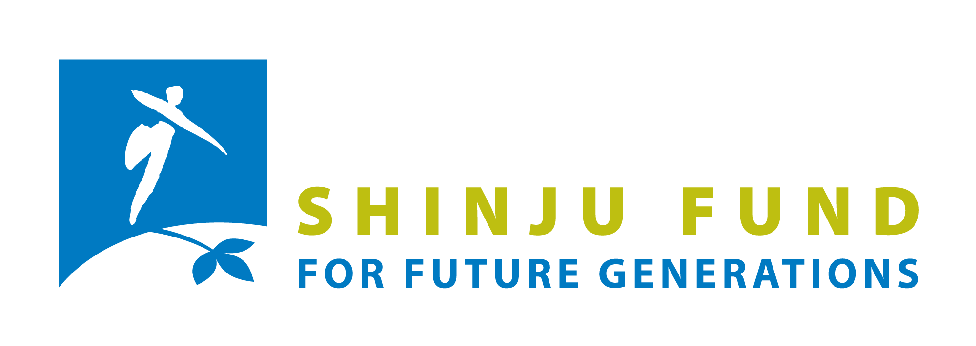

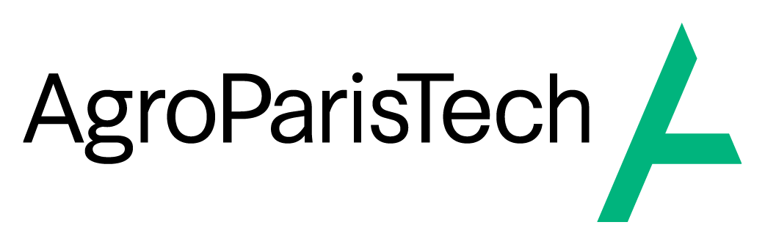

Shinju Fund
Farm, Food, Forest & Biotech
Seed funding for sustainable start-ups with a positive environmental impact

A call for applications from the Shinju Fund of the Foundation for Future Generations, in partnership with AgroParisTech

Application Form
Call for projects 2026 (5th edition)

This application document, as well as the pitch deck (15 slides), mandatory (P&L, CV of team members) and optional annexes must be completed in English or French and uploaded before midnight on the 16th of August 2026 on the Foundation for Future Generations’ website.
On the basis of these elements, the jury will shortlist 5 to 7 projects. Their entrepreneurs, established as a legally entity, will be invited to present their project to the jury on the 2rd of October 2026 in Paris.
Please save the date already!

Please be as clear and concise as possible.
The maximum number of characters for each question is with spaces included.

Legal Entity Identification Form (which must be established by the date of the jury meeting)

Name | Click or tap here to enter text.
Date of establishment | Click or tap here to enter text.
Postal address of headquarters | Click or tap here to enter text.
Legal form | Click or tap here to enter text.
Registration number  SIREN, SIRET, VAT, BCE or equivalent | Click or tap here to enter text.
Turnover for the last financial year | Click or tap here to enter text.
Requested amount ? | Click or tap here to enter text.

SECTION 1 : Description of your project

Project overview
Describe your project in a maximum of 5 lines (the problem you are addressing, your solution, and the environmental impact)
This short pitch might be used in future public communication (newsletter, website, annual report), with your consent, so please be as clear and as concrete as possible.
(300 characters maximum)

Your innovation
Describe your product or service
(600 characters maximum)

What is your Unique Selling Proposition (USP) ? And how is your solution better than existing alternatives ?
(500 characters maximum)

Who are your competitors ? Why have they not already done this ?
Describe how competitive your market is. Please provide the full name and website of all competitors mentioned and their location.
(700 characters maximum)

Why is your solution difficult to replicate ? (technology, intellectual property, data, network effects, know-how, regulation, etc.)

(400 characters maximum)

The objective of the Shinju Fund with this open call is to support projects with high environmental added value, and these impacts will be assessed holistically (360° approach). Where possible, reference will be made to recognized assessment standards and the SDG classification will be used.

Expected environmental impacts and sustainability
What environmental problem(s) are you addressing? Have you identified any potential risks of negative impacts on the environment or on any of the SDGs ?
If relevant, please briefly list and describe potential sustainability-related risks of negative impact related to your activity (environmental, social, governance). If applicable, describe how you plan to mitigate them and ensure a "Do No Significant Harm" approach, with safeguards on e.g. biodiversity, water, health, social equity, or other SDG-related risks.
(400 characters maximum)

Why is/are this/these problem(s) important ?
(200 characters maximum)

Why now ?
(400 characters maximum)

What have you already achieved with very limited resources ?
(200 characters maximum)

What measurable environmental impacts does your solution create ? How do you plan to monitor them ?
Describe and, if possible, quantify the main environmental contributions of your project (e.g., tonnes of CO₂ avoided, hectares restored, reduction in pesticide use, etc.). You can refer to the green taxonomy.
(1000 characters maximum).

What is the main annual impact you aim to achieve in 5 years ?
(200 characters maximum)

What are your other impacts within the broader scope of sustainability ?
Please list the positive impacts, other than the environmental impacts mentioned above, that you are planning to bring to the other dimensions of sustainable development (people, prosperity, participation; the broader scope of the SDGs) and to other stakeholders, in addition to your customers. Please focus on those that are most relevant to your project.
(800 characters maximum)

If you succeed, what will the impact be in 10 years ?
(200 characters maximum)

Stage of development
What is the biggest risk to your project ?
(400 characters maximum)

SECTION 2 : Market and Traction

Who are/will be your customers ?
Describe your early customers and those you could target in the future; specify where and how your product will be sold.
(1000 characters maximum)

Why do customers buy ?
(400 characters maximum)

What is the most encouraging signal you have observed from your customers ?
(400 characters maximum)

What is the size of the target market ?
- Total market
- Initial total market
(600 characters maximum)

Do you foresee any significant changes in your sector over the next few years, particularly in terms of market and regulation? Which impact could this have on your project?

(500 characters maximum)

What traction do you have today?
Indicator | Value
Clients
Monthly turnover
Pilots
Signed contracts
Partnerships and value

SECTION 3 : Economic model
What is your revenue model? How will you set your price?
(400 characters maximum)

What are your unit economics values according to the following indicators?
Indicator | Value
Average price
Production cost
Gross margin

If Shinju did not fund you, what would happen?
(400 characters maximum)

SECTION 4 : Financial information
How would you define the type of your current fundraising round?
Preseed, seed, series A….

What are your financial needs for the next 2 years?
As a reminder, the Shinju loan cannot represent less than 5% and more than 50% of these financial needs.
Expense Category | Corresponding amounts
Research
Development
Recruitment
Equipment

Describe these financial needs and your strategy for fundraising.
Including what has been raised so far; what your personal contribution has been/will be (financial/extra-financial); what is the amount of this current fundraising and its timing; what external funding (investors, banks, grants, etc.) are you trying to obtain.
(800 characters maximum)

Who are the current shareholders and what is the capital structure?
(300 characters maximum)

If you feel it’s necessary, please explain (summarise) the figures provided in the P&L spreadsheet.
Optional question (800 characters maximum)

What are your development plans and their timeframe in the next 2 years? What are the main investments you need to make in that period?
(400 characters maximum)

How will the €50k Shinju loan be used?
Please detail the expenses for which it will be used.
Please describe what this funding would allow you to achieve or unlock that would otherwise be difficult at this stage - for instance, a specific milestone, or access to additional resources. Focus on concrete outcomes.
(400 characters maximum)
Description of the expense | Supplier / Provider (if known) | Amount

At how much do you value your business today?
Please provide details about your assets and their current value, as well as your key valuation criteria. Explain the method used to calculate this valuation, who carried it out, and on what date.
Do you believe this amount is likely to change by the date of the jury?
Please also explain your choice of legal entity type.
(500 characters maximum)

This valuation will be used to assess the development of your company and therefore the amount of any philanthropic contribution to the Shinju Fund. This valuation may be discussed with the partners of the call before the agreement is signed.
For the valuation amount, please indicate a single figure rather than a range.

SECTION 5 : Team
Who is/will be part of the team? With what skills? What will be the respective responsibilities within the company?
Please mention relevant experiences, assets or added values brought by each member and mention whether it is their first activity as entrepreneur.
(800 characters maximum)

Why is your team well positioned to solve the problem you are addressing?
(500 characters maximum)

How and why did you form it?
(500 characters maximum)

Contact persons

Primary contact person
Surname | Click or tap here to enter text.
First name | Click or tap here to enter text.
Date of birth | Click or tap here to enter text.
Nationality(ies) | Click or tap here to enter text.
Street & Number | Click or tap here to enter text.
Postal code and municipality | Click or tap here to enter text.
Country | Click or tap here to enter text.
Telephone number | Click or tap here to enter text.
Email | Click or tap here to enter text.

Other team members
Surname/first name, e-mail | Click or tap here to enter text.
Surname/first name, e-mail | Click or tap here to enter text.
Surname/first name, e-mail | Click or tap here to enter text.

Stay in touch: I'd like to...
☐ Subscribe to the Foundation for Future Generations's newsletter (~ 4 times a year, unsubscribe on request)
☐ Subscribe to the AgroParisTech newsletter

Complementary Philanthropic Contribution Mechanism
Shinju winners that experience significant growth are invited to support the Shinju Fund in return. This contribution is intended to offset the losses inherent in early-stage financing and to enable the Fund to continue supporting new environmental impact startups.
The calculation mechanism is detailed in the Shinju “Presentation & Guidelines” document (section “Additional philanthropic contribution”). It is based on the evolution of the company’s valuation between the start and the end of the loan. This capped contribution depends on the level of success achieved and remains modest in relation to the value created.
☐ In the event of success of my project, I agree to this additional philanthropic contribution, as well as to the proposed mechanism for calculating its amount.

Appendices

Mandatory appendices, in English or French:
- CV (A4 format in PDF, max 2 pages) of the team members concerned (max 3 members).

- Profit and Loss (P&L) excel spreadsheet including the previous year and the next 4 years (You may adapt this template to your situation, but please keep it concise).

- Pitch deck/investor deck (15 slides), in PDF-format. This is an investor presentation of maximum 15 slides. The content and layout of the slides are at your discretion. Please ensure that this presentation accurately reflects the key information you wish to convey to the jury.

Optional appendices
You can add any document, table, diagram, or image that you feel is helpful to understanding your project. This is especially suggested for technical projects.

Protection of privacy
Your personal data will be stored in the database of the Foundation for Future Generations, and will only be used to send you information regarding Shinju-related activities and the Foundation's actions in the field of impact entrepreneurship. The Foundation will not share this data with third parties. In accordance with the GDPR, you can ask the Foundation to access, modify or delete this data at any time.
You will find an appendix on the Rights and Management of Applicants’ Personal Data in the “Presentation & Guidelines” document.
All members of the jury sign a confidentiality agreement, and the partners of this call for applications will ensure that no information from this file is revealed or passed on to third parties.

The funds granted by Shinju are part of a broader fundraising round. The amount awarded to a winning startup will only be released once it demonstrates proof of co-financing enabling it to achieve its objectives.

